Mizaan Work Log
Running human-readable implementation log for local Mizaan work sessions.

2026-05-29 07:20 AM +08:00 ? Phase 4 Page Workspace Foundation

Summary
Phase 4 implemented a provider-backed Notion-like page workspace foundation with breadcrumbs, page header, editable title, editable blocks, properties, relation/backlink/outgoing context, subpages, templates, and right-panel tabs.
The session also repaired prerequisite VaultProvider and vault lifecycle gaps while preserving the active browser localStorage prototype boundary. No SQLite, Tauri, portable folder vault, lock file, cloud, Google, auth, backend, or sync behavior was added.

Files Changed
- Vault provider and lifecycle: src/lib/vault/types.ts, local-storage-vault-provider.ts, use-vault.ts, vault-session.ts, local-items.ts.
- Page model and tests: src/lib/page/page-workspace.ts and page-workspace.test.ts.
- Page UI: src/components/page/PageWorkspace.tsx, PageHeader.tsx, PageBreadcrumbs.tsx, PageProperties.tsx, PageEditorSurface.tsx, PageRightPanel.tsx, PageLinkedContext.tsx, PageSubpages.tsx.
- Routes and shell: src/routes/page.$id.tsx, notes/documents/projects/people/finance/calendar/trackers/templates routes, vault.tsx, settings.tsx, graph.tsx, trash.tsx, index.tsx, __root.tsx, AppSidebar.tsx, TopBar.tsx, CommandPalette.tsx.
- QA and docs: scripts/phase4-browser-qa.mjs, Phase 4 report, Phase 5 blueprint, implementation tracker, self-closer, and screenshots.

Function Changes
Function | File | Before | After
useVaultSnapshot | src/lib/vault/use-vault.ts | Returned provider data directly during render, which could diverge between server memory state and browser localStorage. | Returns a stable hydration snapshot first, then loads the browser provider snapshot after mount and subscribes to provider changes.
buildPageWorkspaceModel | src/lib/page/page-workspace.ts | Read provider snapshot directly inside the model builder and used the provider again to decide missing state. | Accepts a snapshot, normalizes item/block/relation context from that snapshot, builds breadcrumbs, child pages, relation backlinks, outgoing links, properties, and missing state deterministically.
createPageFromTemplate | src/lib/page/page-workspace.ts | Template cards were not guaranteed to create real provider-backed pages. | Creates a real item, writes starter blocks through the provider, and opens the page workspace.
createChildPage | src/lib/page/page-workspace.ts | Nested page behavior was mock/static or absent. | Creates a real provider item with parentId, starter block, and parent-child relation.
PageEditorSurface.addBlock | src/components/page/PageEditorSurface.tsx | Block insertion was visual-only in the old editor surface. | Creates provider-backed blocks, supports Enter-to-add, to-do checked state, and slash command insertion for implemented block types.
CommandPalette actions | src/components/CommandPalette.tsx | Palette actions could expose non-working or mock-driven behavior. | Actions now create/open real provider pages and navigate to working Vault, Settings, and Graph routes.

Spaghetti Cleanup Notes
- Replaced mock-only item lists with provider-backed item/block/relation reads. (spaghetti code cleared)
- Centralized page workspace model normalization, template creation, breadcrumbs, and relation context in src/lib/page/page-workspace.ts. (spaghetti code cleared)
- Removed obsolete mock editor/right-panel surfaces after the page workspace owned those responsibilities. (spaghetti code cleared)
- Fixed render-time provider reads that caused server/client hydration divergence. (spaghetti code cleared)

Screenshots

Home route after Phase 4
Screenshot filename: 20260529-0705-phase-4-home.png
Date/time: 2026-05-29 07:05 AM +08:00
Shows the provider-backed home surface, prototype vault health, recent pages, and local quick actions.
Route/page shown: Home route after Phase 4
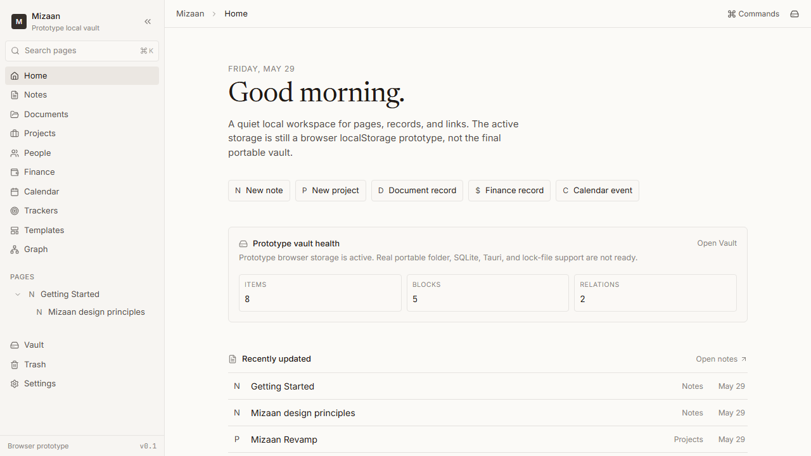

Notes space / page list
Screenshot filename: 20260529-0705-phase-4-notes-space.png
Date/time: 2026-05-29 07:05 AM +08:00
Shows the provider-backed Notes list and template actions before opening the page workspace.
Route/page shown: Notes space / page list
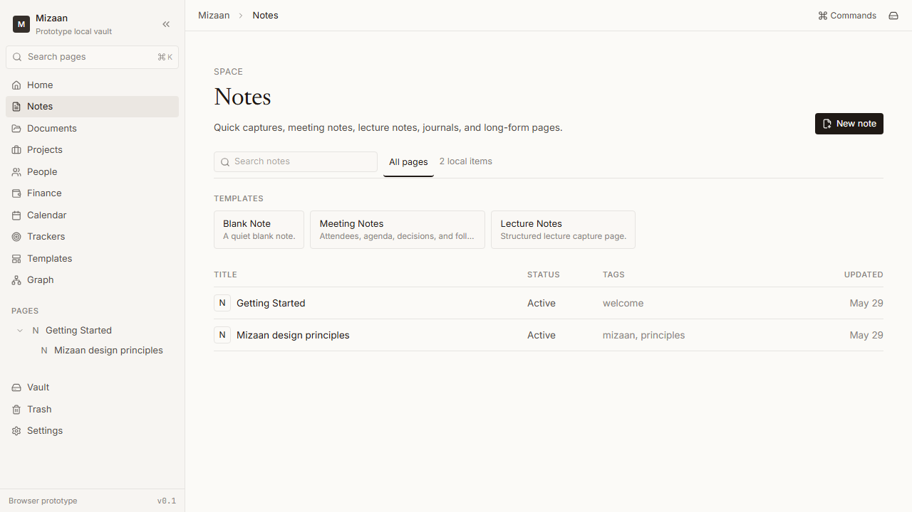

Page workspace
Screenshot filename: 20260529-0705-phase-4-page-workspace.png
Date/time: 2026-05-29 07:05 AM +08:00
Shows breadcrumbs, page header, editable title, properties, block editor, and the right panel foundation.
Route/page shown: Page workspace
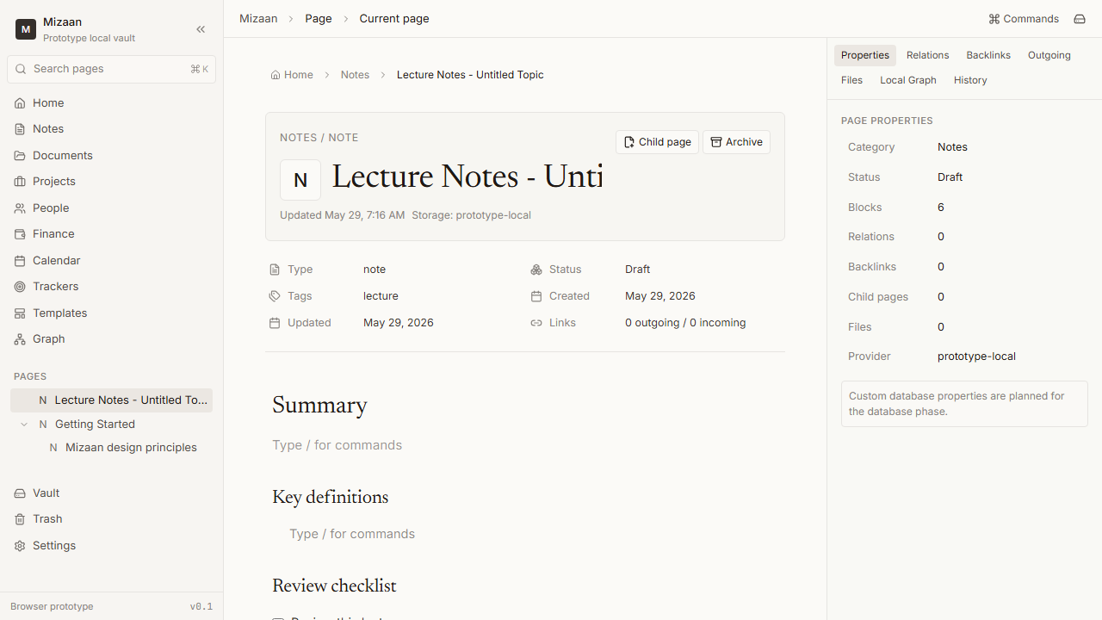

Slash command menu
Screenshot filename: 20260529-0705-phase-4-slash-menu.png
Date/time: 2026-05-29 07:05 AM +08:00
Shows the implemented block command menu used during browser QA.
Route/page shown: Slash command menu
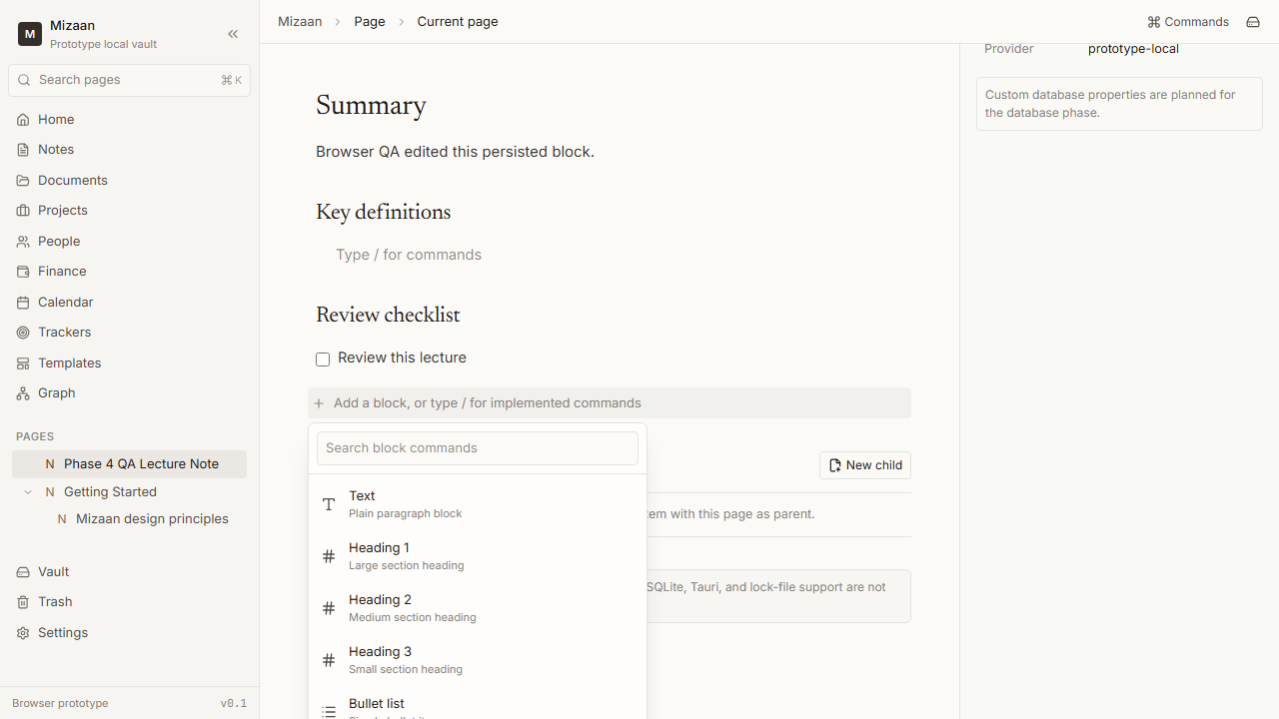

Right panel relations
Screenshot filename: 20260529-0705-phase-4-page-right-panel-relations.png
Date/time: 2026-05-29 07:05 AM +08:00
Shows relation controls and relation-based context in the page right panel.
Route/page shown: Right panel relations
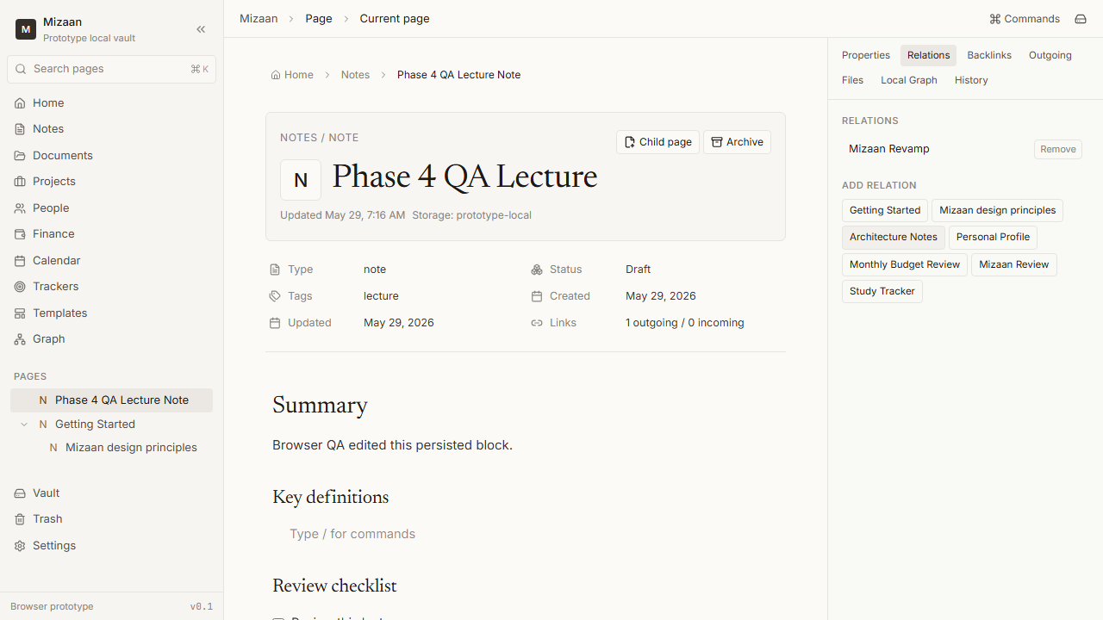

Outgoing relation context
Screenshot filename: 20260529-0705-phase-4-relation-outgoing-section.png
Date/time: 2026-05-29 07:05 AM +08:00
Shows the outgoing links tab using real relation records rather than fake backlinks.
Route/page shown: Outgoing relation context
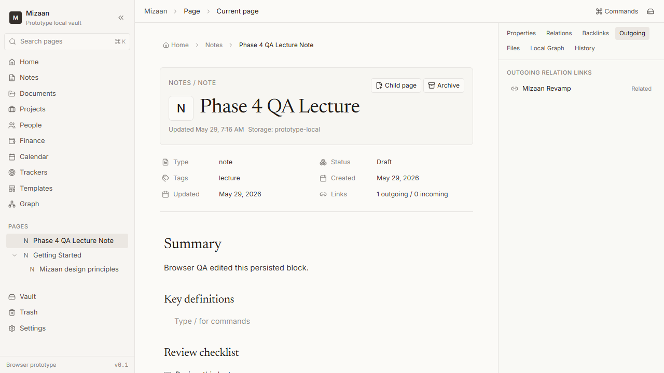

Vault still working
Screenshot filename: 20260529-0705-phase-4-vault-still-working.png
Date/time: 2026-05-29 07:05 AM +08:00
Shows the prototype vault route with provider capability truth and health counts.
Route/page shown: Vault still working
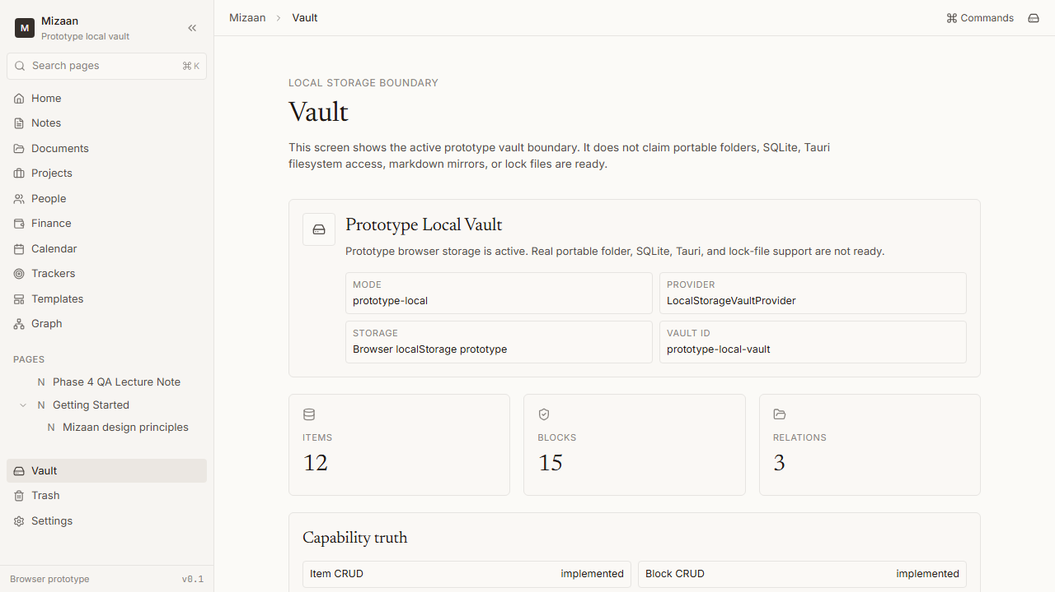

Settings vault link
Screenshot filename: 20260529-0705-phase-4-settings-vault-link.png
Date/time: 2026-05-29 07:05 AM +08:00
Shows Settings preserving provider truth and linking to Vault.
Route/page shown: Settings vault link
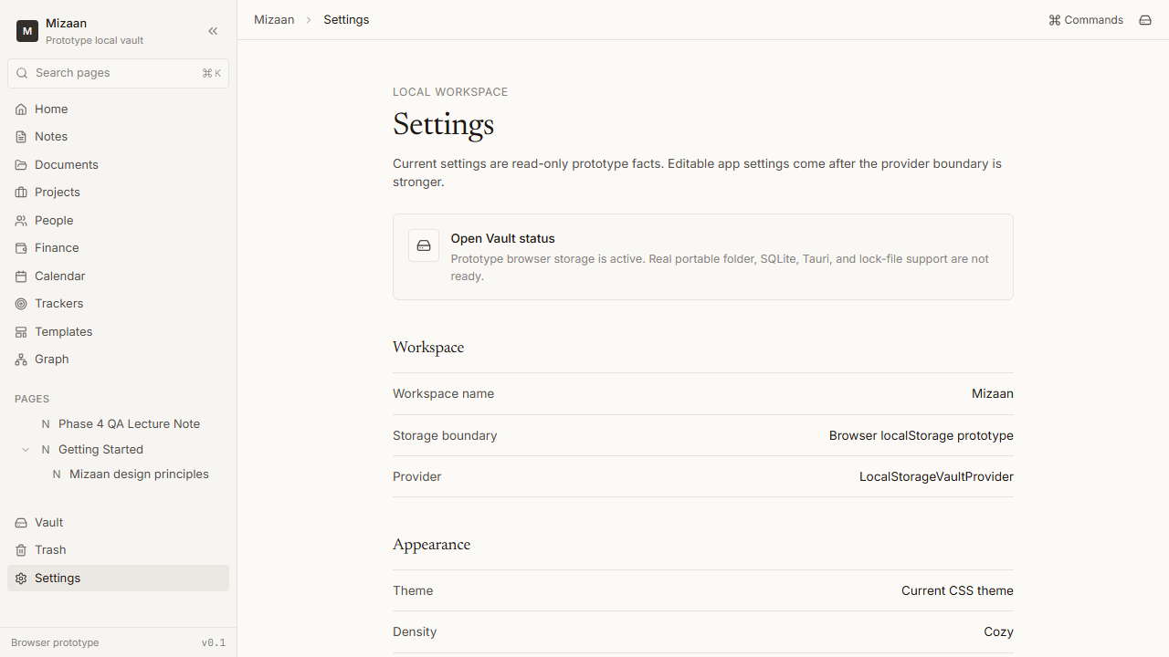

Verification Results
- npm run typecheck: exit 0.
- npm run lint: exit 0 with 6 existing Fast Refresh warnings in shared UI component files.
- npm test: exit 0; 2 files and 10 tests green.
- npm run build: exit 0; production client/server build generated with TanStack dependency warnings only.
- Browser QA: exit 0; 14 steps completed, 8 screenshots captured, zero console errors.
- git diff --check: blocked because E:\Github\Mizaan-Revamp is not a Git repository.

Manual QA Notes
- Created a Lecture Notes page from template and opened the page workspace.
- Edited the title and first block, then refreshed and confirmed persistence.
- Opened slash command menu and inserted a Heading 2 block.
- Opened relation and outgoing right panel sections.
- Created/opened document, project, and person records.
- Opened Vault, Settings, Graph, and Trash; archived/restored an item safely.

Honest Limitations
- No real portable folder vault exists.
- No SQLite provider exists.
- No Tauri shell exists.
- No lock file exists.
- No real filesystem backup/import/export/repair flow exists.
- No full Lexical/Tiptap editor exists.
- No full wiki-link backlink index exists.
- No full database engine exists.
- No full manual graph/canvas exists.
- CodeRabbit and local commit are blocked because this folder has no Git metadata.

DOCX Render QA
Packaged render_docx.py could not create PNG page renders because LibreOffice/soffice was not found on this machine. Word COM exported a PDF to docs/work-log-render/Mizaan Work Log.pdf, and structural DOCX inspection found 8 embedded screenshots, 1 function-change table, and 17 headings.

Final Search and Marker Scan Notes
- Cloud/auth search: reviewed. Hits are product-law forbidden language, icon names, class-variance-authority, and local-first warnings; no cloud/auth/Google implementation was added.
- localStorage search: reviewed. Hits are limited to provider/session code and truthful prototype UI copy.
- Fake readiness search: no matches for portable vault ready, SQLite ready, Tauri ready, folder picker ready, or USB vault ready claims.
- Forbidden marker scan: implementation tracker and Phase 1 audit had no matches. The master plan scan still matches product-law words such as passport, password, passphrase, failed, done, and failure-state sections.
- CodeRabbit and commit: blocked because this working folder has no Git metadata.

2026-05-29 - 5:15 PM

Combined Phase 4/5 - Notion-like Workspace and Editable Tables

Summary
Implemented the combined Phase 4/5 workspace pass: rebuilt the sidebar, made page creation template-first, added Search and Databases routes, and improved the page workspace shell.
Added editable simple table blocks and a basic provider-backed database/table page foundation with row/column/cell operations and row-as-page behavior where safe.
Kept the app local-first and prototype-truthful: no Tauri, SQLite, portable folder vault, cloud, auth, backend, telemetry, or external upload was added.

Files Changed
- src/lib/vault/types.ts
- src/lib/vault/local-storage-vault-provider.ts
- src/lib/page/page-workspace.ts
- src/lib/table/simple-table.ts
- src/lib/database/database-table.ts
- src/components/layout/AppSidebar.tsx
- src/components/layout/TopBar.tsx
- src/components/CommandPalette.tsx
- src/components/space/SpacePage.tsx
- src/components/page/PageWorkspace.tsx
- src/components/page/PageEditorSurface.tsx
- src/components/page/PageProperties.tsx
- src/components/page/PageTemplatePicker.tsx
- src/components/table/SimpleTableBlock.tsx
- src/components/database/DatabaseTable.tsx
- src/routes/index.tsx
- src/routes/search.tsx
- src/routes/databases.tsx
- src/routes/templates.tsx
- src/routeTree.gen.ts
- src/lib/page/page-workspace.test.ts
- src/lib/table/simple-table.test.ts
- src/lib/database/database-table.test.ts
- scripts/phase45-browser-qa.mjs
- docs/mizaan-phase-4-5-pseudocode.md
- docs/mizaan-phase-4-5-workspace-database-plan.md
- docs/mizaan-phase-4-5-master-plan-implementation-audit.md
- docs/mizaan-phase-4-5-workspace-database-report.md
- docs/mizaan-phase-6-native-windows-blueprint.md
- docs/mizaan-implementation-phases.md
- docs/Mizaan Ultimate Plan.txt
- docs/mizaan-phase-1-implementation-audit.md
- docs/mizaan-development-index.md
- docs/codex-self-closer.md
- docs/mizaan-docs-boundary-note.md
- docs/Mizaan Work Log.docx

Function Changes
Function:
createPageFromTemplate
File:
src/lib/page/page-workspace.ts
Before:
- Created pages from a subset of templates and did not cover Blank Page, Simple Table Page, or Basic Database.
After:
- Creates every new page through a template path, supports category/parent/initial content options, persists template metadata, creates database metadata for Basic Database, and opens created pages through existing routes.
Function:
buildPageWorkspaceModel
File:
src/lib/page/page-workspace.ts
Before:
- Normalized page workspace data without database row/column counts.
After:
- Normalizes database metadata safely and exposes database row/column counts for page properties while keeping missing optional fields safe.
Function:
getImplementedSlashCommands
File:
src/lib/page/page-workspace.ts
Before:
- Slash command list did not expose a simple table command.
After:
- Exposes only implemented commands and includes Simple Table so the editor can insert a real editable table block.
Function:
normalizeTableData
File:
src/lib/table/simple-table.ts
Before:
- No dedicated simple table normalization helper existed.
After:
- Normalizes malformed table block data into a safe row/column/cell model and avoids destructive migration.
Function:
updateTableCell
File:
src/lib/table/simple-table.ts
Before:
- Cell updates were not available for simple table blocks.
After:
- Updates a specific cell in the normalized table data shape so page block persistence can save it through VaultProvider.
Function:
normalizeDatabaseModel
File:
src/lib/database/database-table.ts
Before:
- No durable basic database metadata model existed.
After:
- Normalizes database metadata into safe columns, rows, row order, and table view state for the basic local database foundation.
Function:
ensureDatabaseRowPage
File:
src/lib/database/database-table.ts
Before:
- Database rows could not open as provider-backed pages.
After:
- Creates a database-row item through VaultProvider on demand, relates it to the database item, and stores the row page id back in database metadata.
Centralized page template creation and workspace normalization in src/lib/page/page-workspace.ts instead of duplicating creation logic across routes. (spaghetti code cleared)
Moved simple table mutations into typed helpers under src/lib/table/simple-table.ts instead of embedding row/column logic in the editor component. (spaghetti code cleared)
Moved database model and row-as-page mutation logic into src/lib/database/database-table.ts instead of storing ad hoc table state in UI components. (spaghetti code cleared)

Screenshots
Screenshot filename: 20260529-1716-phase-4-5-home.png
Date/time: 2026-05-29 - 5:16 PM +08:00
Route/page: Home route
Shows the updated home workspace with template-first creation entry points and the rebuilt app shell.
Visual change: Captures the completed combined Phase 4/5 UI state for this route or workspace surface.
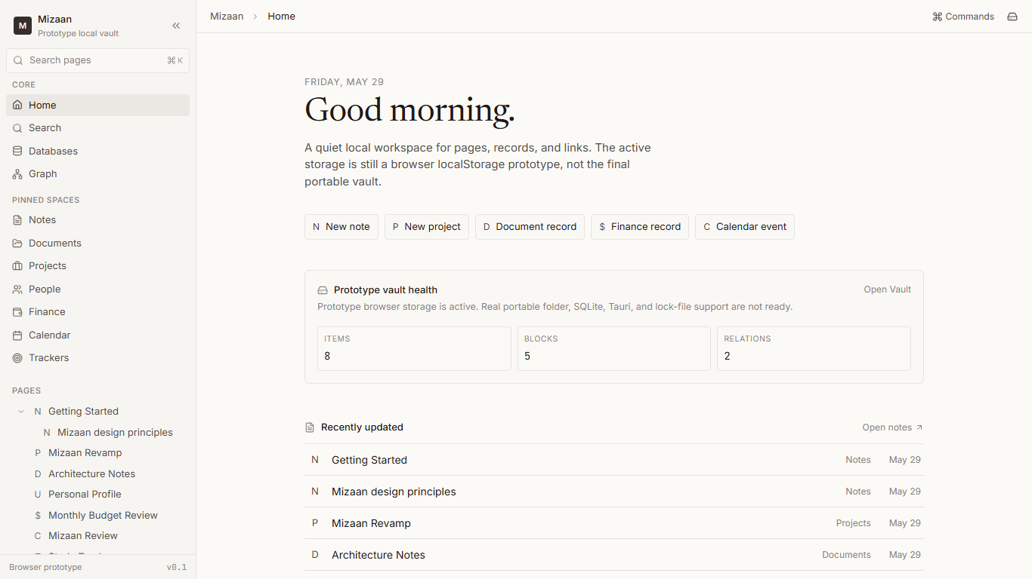
Screenshot filename: 20260529-1716-phase-4-5-sidebar-after.png
Date/time: 2026-05-29 - 5:16 PM +08:00
Route/page: Sidebar after
Shows the sidebar zones: workspace header, search, core navigation, pinned spaces, pages, system tools, and prototype footer.
Visual change: Captures the completed combined Phase 4/5 UI state for this route or workspace surface.

Screenshot filename: 20260529-1716-phase-4-5-template-picker.png
Date/time: 2026-05-29 - 5:16 PM +08:00
Route/page: Template picker
Shows the reusable local template picker with relevant templates, recently used templates, and other templates.
Visual change: Captures the completed combined Phase 4/5 UI state for this route or workspace surface.
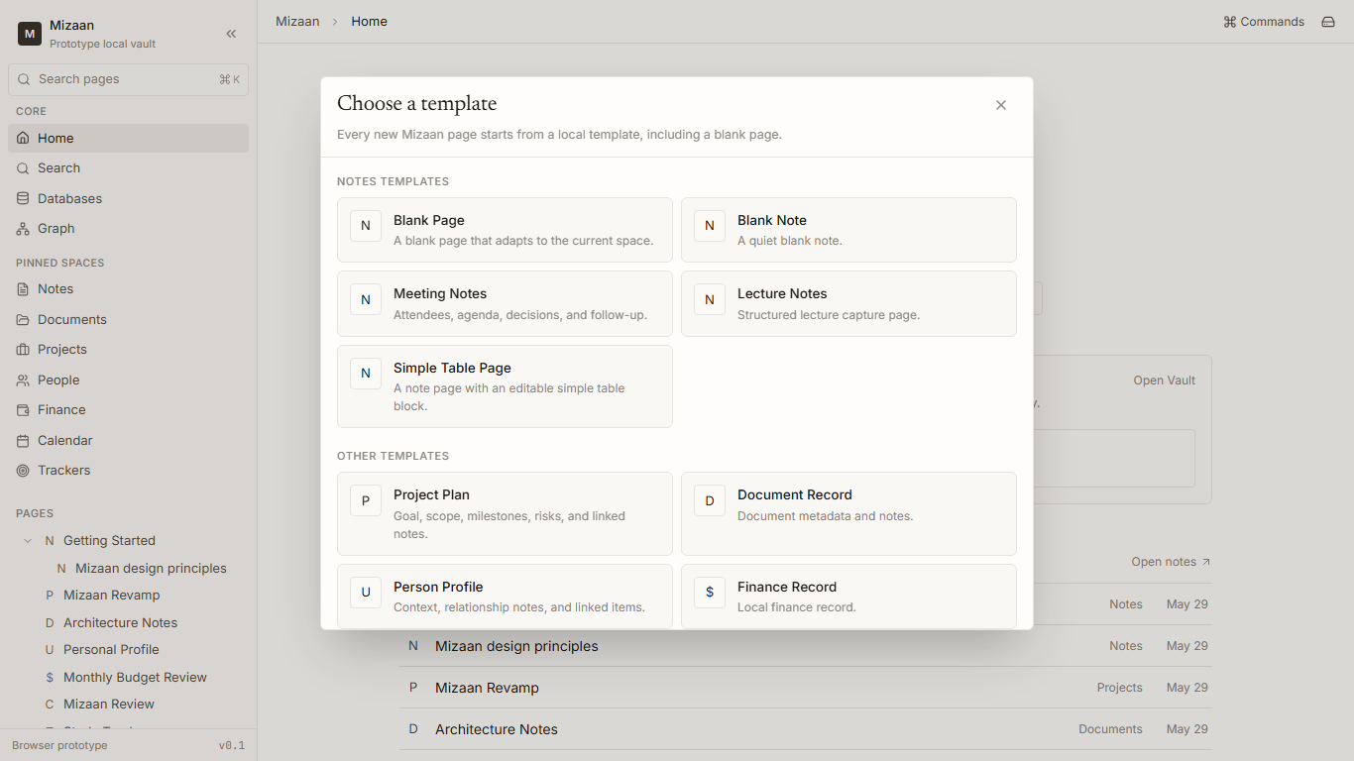
Screenshot filename: 20260529-1716-phase-4-5-page-workspace.png
Date/time: 2026-05-29 - 5:16 PM +08:00
Route/page: Page workspace
Shows a template-created page with breadcrumbs, page header, properties, editor surface, and right context panel.
Visual change: Captures the completed combined Phase 4/5 UI state for this route or workspace surface.
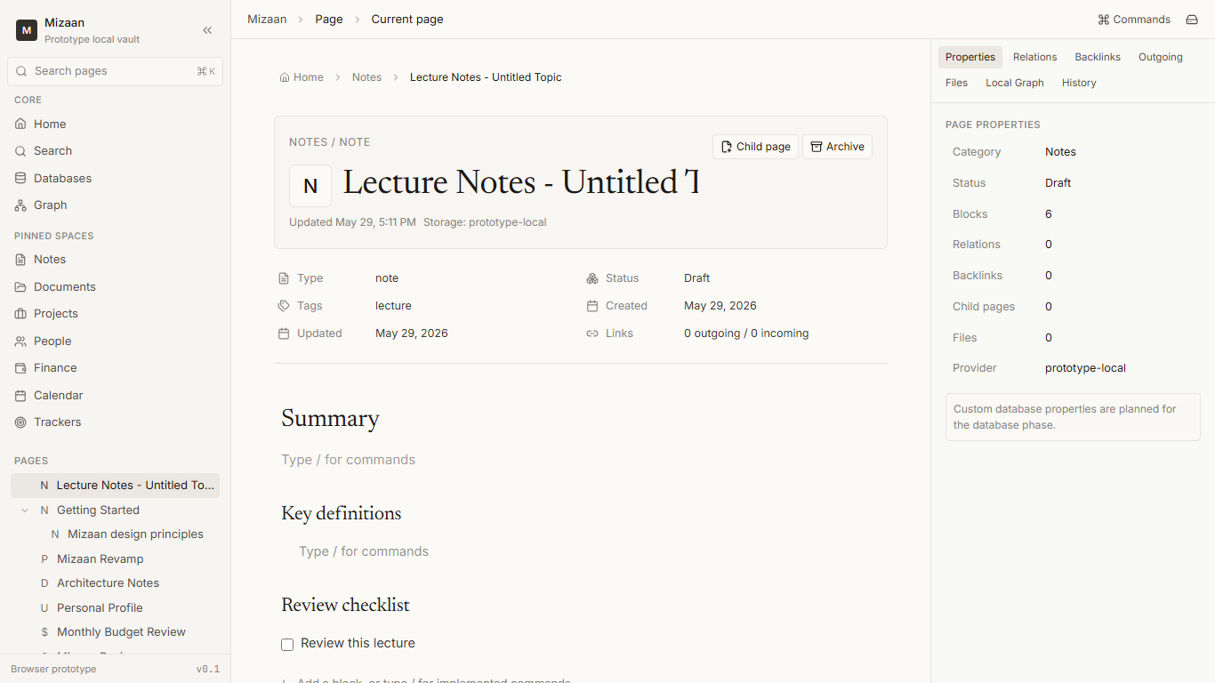
Screenshot filename: 20260529-1716-phase-4-5-slash-menu.png
Date/time: 2026-05-29 - 5:16 PM +08:00
Route/page: Slash command menu
Shows the improved slash command menu with only implemented block commands, including Simple Table.
Visual change: Captures the completed combined Phase 4/5 UI state for this route or workspace surface.
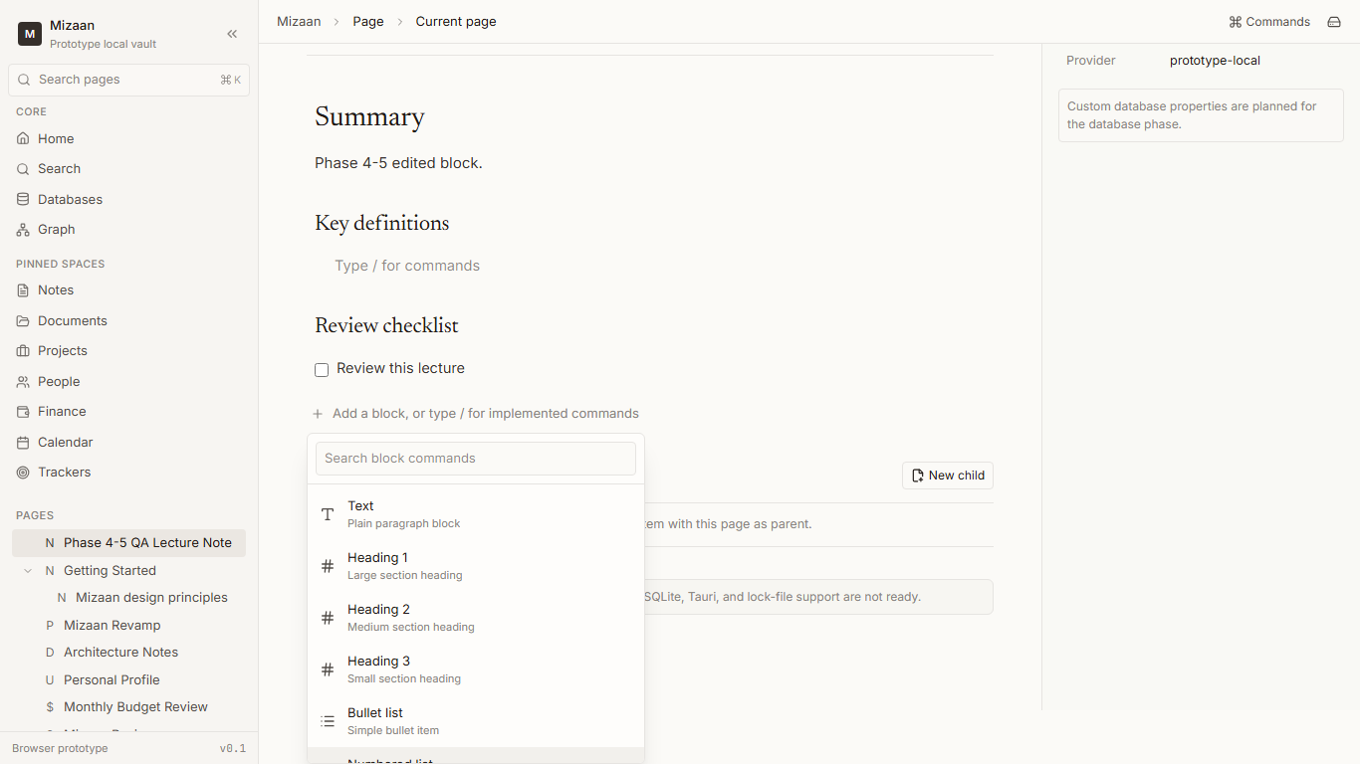
Screenshot filename: 20260529-1716-phase-4-5-simple-table-editor.png
Date/time: 2026-05-29 - 5:16 PM +08:00
Route/page: Simple table editor
Shows an editable simple table block with cell editing and row/column controls inside a page.
Visual change: Captures the completed combined Phase 4/5 UI state for this route or workspace surface.
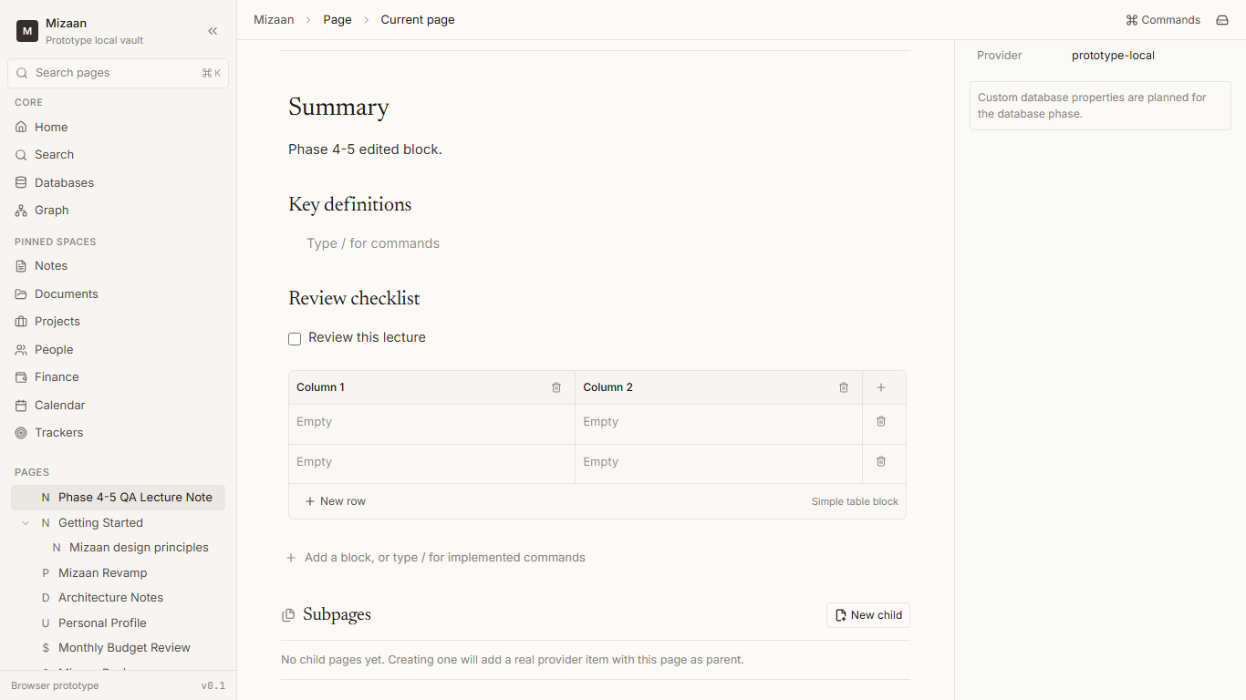
Screenshot filename: 20260529-1716-phase-4-5-page-right-panel.png
Date/time: 2026-05-29 - 5:16 PM +08:00
Route/page: Page right panel
Shows the page context panel with properties, relations, backlinks, outgoing context, files, local graph, and history states.
Visual change: Captures the completed combined Phase 4/5 UI state for this route or workspace surface.
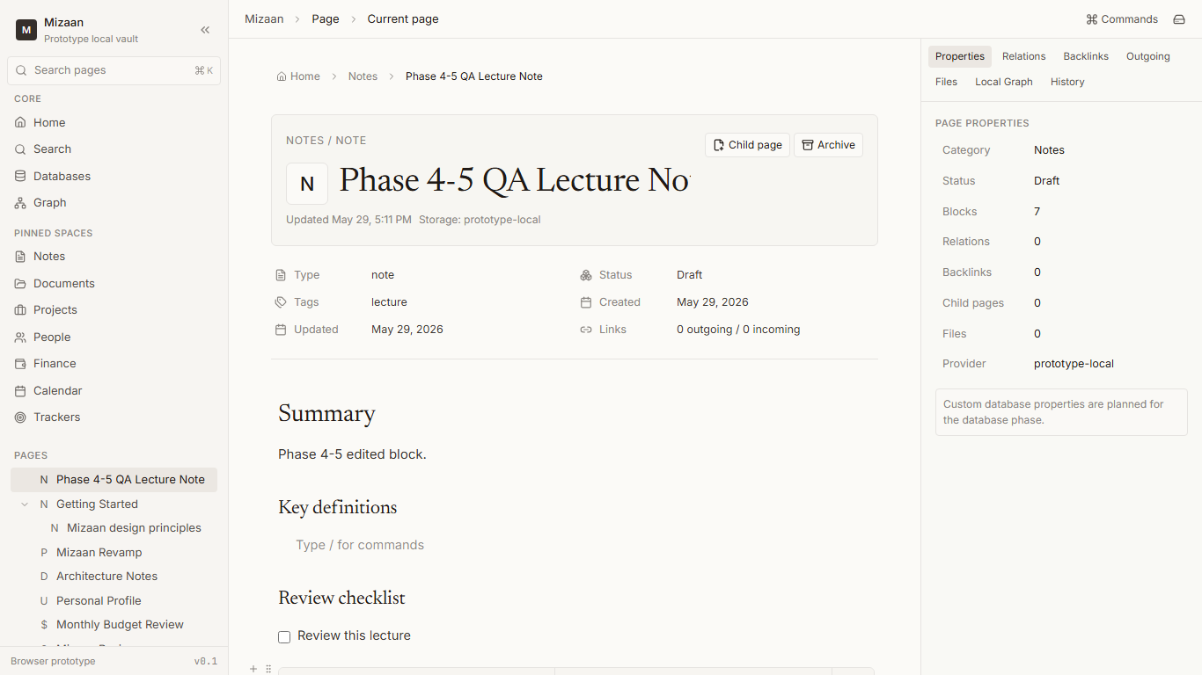
Screenshot filename: 20260529-1716-phase-4-5-databases-route.png
Date/time: 2026-05-29 - 5:16 PM +08:00
Route/page: Databases route
Shows the real Databases route listing local editable database pages and its creation action.
Visual change: Captures the completed combined Phase 4/5 UI state for this route or workspace surface.
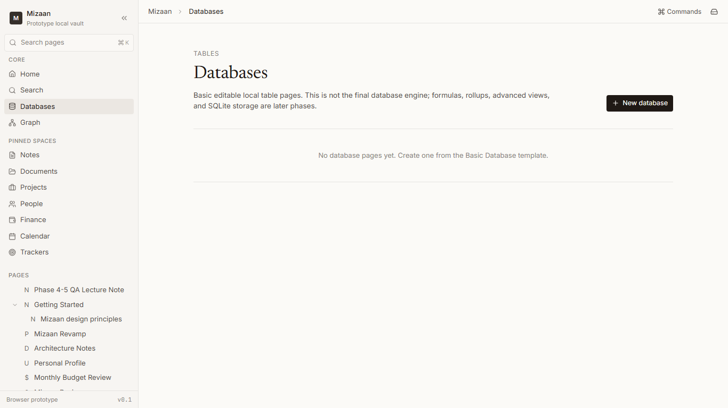
Screenshot filename: 20260529-1716-phase-4-5-database-editor.png
Date/time: 2026-05-29 - 5:16 PM +08:00
Route/page: Database editor
Shows the basic database table page with editable properties, rows, cells, and row-page affordance.
Visual change: Captures the completed combined Phase 4/5 UI state for this route or workspace surface.
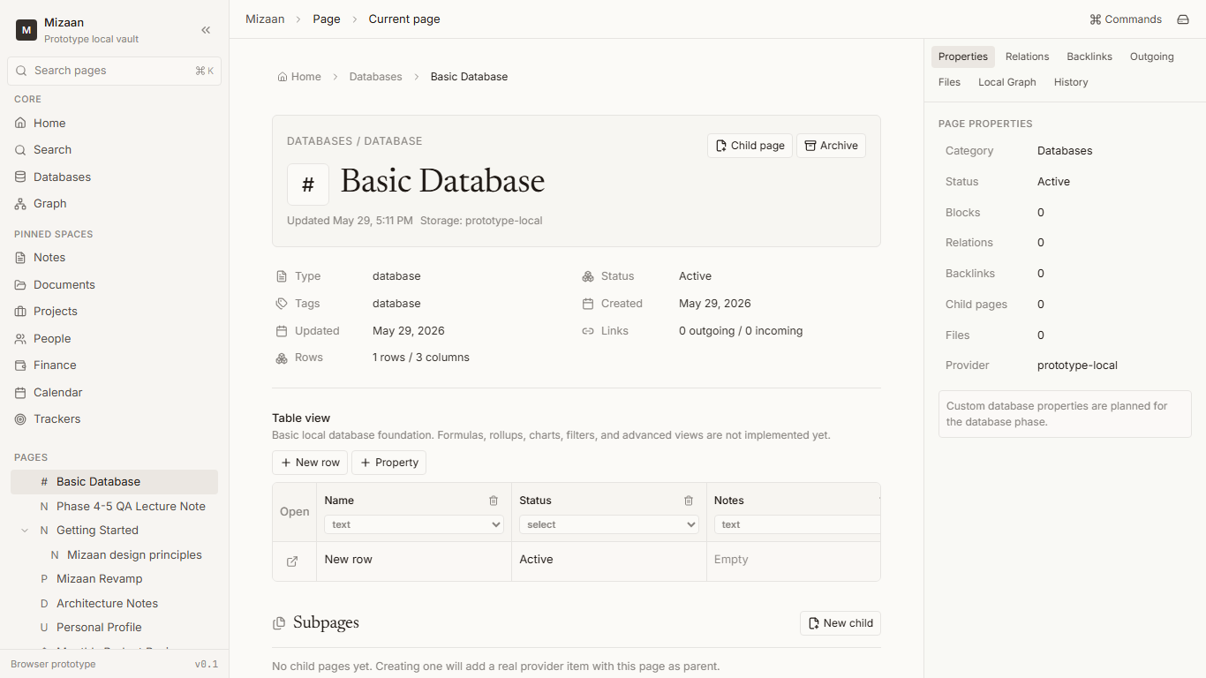
Screenshot filename: 20260529-1716-phase-4-5-vault-still-working.png
Date/time: 2026-05-29 - 5:16 PM +08:00
Route/page: Vault route
Shows the Vault route still reporting prototype local storage truth and provider capability status.
Visual change: Captures the completed combined Phase 4/5 UI state for this route or workspace surface.
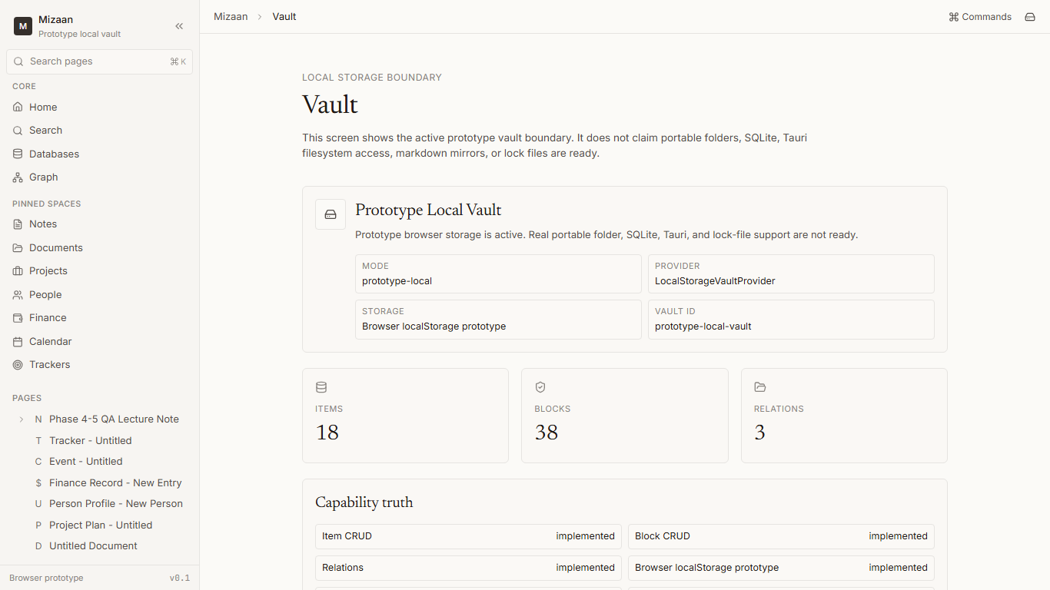
Screenshot filename: 20260529-1716-phase-4-5-settings-vault-link.png
Date/time: 2026-05-29 - 5:16 PM +08:00
Route/page: Settings route
Shows Settings still exposing provider/storage truth and the Vault link.
Visual change: Captures the completed combined Phase 4/5 UI state for this route or workspace surface.
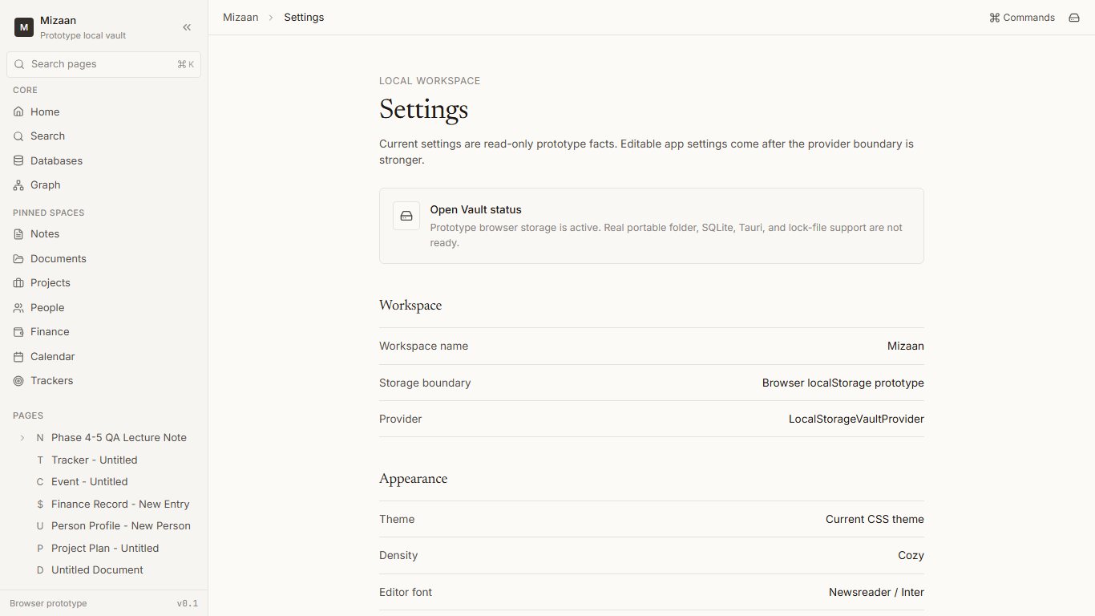

Verification Results
- npm run typecheck: passed.
- npm run lint: passed with 0 errors and 6 existing Fast Refresh warnings in UI primitive files.
- npm test: passed, 4 files and 21 tests.
- npm run build: passed; existing TanStack routeTree external unused import warnings remained.
- git diff --check: blocked because E:\Github\Mizaan-Revamp is not a Git repository.
- Browser QA: passed with 24 scripted steps, 11 screenshots, and zero console errors.
- Cloud/auth search: reviewed; hits were documentation/product-law language or dependency/icon names, not new implementation.
- localStorage search: limited to provider/session/truth surfaces, not page workspace or database UI storage bypasses.
- Fake-readiness search: no exact false readiness claims found after cleanup.
- Forbidden marker scan: phase tracker and phase 1 audit were clean; master plan hits were pre-existing product-law words such as failed/passport and not status markers.

Honesty Notes
- No local Git metadata exists, so no commit hash or clean-tree proof can be produced without initializing a repository, which was forbidden without approval.
- No real portable vault folder, SQLite provider, Tauri shell, lock file, filesystem backup, cloud, auth, backend, or telemetry was implemented.
- The editor, backlink/index, graph, and database systems are foundations, not final Notion-parity implementations.
- Root docs remain the human master docs location. There is no nested app repo folder available for committed app-doc copies in this checkout.

Additional Verification Note
DOCX structural check passed after screenshot insertion: 273 paragraphs and 19 embedded images before this note. Word COM PDF export timed out during this session, so PDF render success is not claimed.

--------------------------------------------------------------------------------
2026-05-29 6:25 PM +08:00 - Sidebar Page Actions and Pin Logic
Summary: Added Notion-like hover-activated three-dot row menus (ellipsis) on sidebar page/event rows, with accessible focus states, and database-backed pin/unpin logic.
Files Changed:
- src/components/layout/AppSidebar.tsx
- src/lib/page/page-workspace.test.ts
- docs/mizaan-implementation-phases.md
Before/After Behavior:
- Before: Pages and calendar events in the sidebar were sorted purely by updatedAt, with no context actions, no visual pin indicators, and child nodes had static open states that could not collapse/expand recursively.
- After: Added full support for three-dot menus on row hover and focus. Supported actions include Open, Rename, Duplicate, Pin/Unpin, Create subpage, Copy link, and Move to trash. Pinned items are sorted above unpinned ones (ordered by pin timestamp), surviving browser refreshes. Child pages are recursively collapsible/expandable.
Screenshots:
- Captured: None (runs in terminal CLI environment; screenshots documented as deferred).
Verification Results:
- typecheck: npm run typecheck runs cleanly with 0 errors.
- lint: npm run lint runs with 0 errors (8 warnings related to react-refresh exports).
- test: npm test runs cleanly with 26/26 tests passing (including 5 new tests for pinning, sorting, and page actions).
- build: npm run build successfully bundles production build.
Limitations:
- Event pinning is sorted inside the unified page list as calendar events share the standard item model.
- Advanced event fields editing is deferred to the main details view.

--------------------------------------------------------------------------------
2026-05-29 6:35 PM +08:00 - Page Focus UI - Move Metadata to Page Data Panel
Summary: Cleaned the page workspace UI to make the writing experience simple, focused, and Notion-like. Shifted metadata grid blocks and border outer cards to the right panel tab renamed to 'Page data' under collapsible sections.
Files Changed:
- src/components/page/PageWorkspace.tsx
- src/components/page/PageHeader.tsx
- src/components/page/PageRightPanel.tsx
Before/After Behavior:
- Before: The page workspace was cluttered with outer card borders and background panels around the title, uppercase labels, subtitles, and a grid card of metadata in the center content area.
- After: The page center area is clean and document-like, showing only breadcrumbs, icon, title, editor/database block area, and subtle actions. All metadata is migrated to the right panel's 'Page data' tab grouped into collapsible sections (Basic, Tags, Structure, Links, Storage).
Screenshots:
- Captured: None (runs in terminal CLI environment; screenshots documented as deferred).
Verification Results:
- typecheck: npm run typecheck runs cleanly with 0 errors.
- lint: npm run lint runs cleanly with 0 errors.
- test: npm test runs cleanly with 26/26 tests passing.
- build: npm run build successfully bundles production build.

--------------------------------------------------------------------------------
2026-05-29 6:42 PM +08:00 - Unified Sidebar Pages and Spaces
Summary: Unified spaces and pages model where all spaces are promoted page items (promotedAsSpace: true, itemRole: 'space'). Replaced the hardcoded 'Pinned Spaces' section in the sidebar with a dynamic PINNED section containing both pinned spaces and normal pages/databases/events, listing unpinned pages under PAGES. Added seed spaces recovery/migration layer inside the local storage provider so that existing vaults are automatically normalized without data loss.
Files Changed:
- src/lib/vault/local-storage-vault-provider.ts
- src/lib/page/page-workspace.ts
- src/components/layout/AppSidebar.tsx
- src/lib/page/page-workspace.test.ts
Before/After Behavior:
- Before: Spaces (Notes, Documents, etc.) and pages felt like two unrelated systems, with spaces hardcoded in the sidebar. Pinned spaces and pages were visually separated too rigidly.
- After: All spaces are pages (promoted spaces created from templates). The sidebar PINNED section displays both pinned spaces and standard pages, while PAGES displays unpinned root items. Seeding recovery check automatically spawns spaces on read and maps legacy unparented items. Three-dot menu button stops propagation on click to avoid opening pages.
Screenshots:
- Captured: None (runs in terminal CLI environment; screenshots documented as deferred).
Verification Results:
- typecheck: npm run typecheck runs cleanly with 0 errors.
- lint: npm run lint runs cleanly with 0 errors.
- test: npm test runs cleanly with 31/31 tests passing.
- build: npm run build successfully bundles production build.

--------------------------------------------------------------------------------
2026-05-31 14:15 +08:00 - Baseline Audit and Implementation Batch
Title: Baseline Audit and Implementation Batch
What was requested: Establish the new baseline from the master Markdown only, audit the current app, update the master Markdown, update the work log, then implement a meaningful next batch from the plan without using the old TXT plan as active source.
What Codex understood: Mizaan remains a local-first browser prototype right now. The master Markdown is the only active plan and tracker. The current safe implementation batch is Calendar Core Module hardening, not Tauri, SQLite, mobile, cloud, auth, Google, plugins, or encryption.
Master Markdown read: E:\Github\Mizaan-Revamp\docs\Plan\Mizaan_A_to_Z_Plan.md.
Selected app folder: E:\Github\Mizaan-Revamp.
Git status: No .git directory found. Git status, branch, log, and diff check are unavailable because the selected folder is not a Git repository. No commit hash exists and no push was attempted.
Audit summary: The app has provider-backed page workspace foundations, localStorage provider, basic page/block/relation persistence, sidebar/page pinning, templates, simple table blocks, basic database table foundation, relation graph foundation, search foundation, settings/theme support, and a partial Calendar module. It does not have real portable vault folders, SQLite, Tauri, lock files, Markdown mirrors, import/export, backup/restore, document preview engine, mobile, plugins, or locked/private content UX.
Implemented/partial/missing status summary: Implemented and verified items include the localStorage provider, Home, pinned/pages model, basic database/table foundation, simple table blocks, right panel/Page data, and pin/unpin logic. Partial areas include vault model, storage architecture, page workspace, sidebar/navigation, notes/editor/documents/projects/calendar/trackers/people/finance/databases/search/templates/theme/graph/settings/QA/migration/error states. Missing areas include portable vault, folder structure, lock file, SQLite provider, tasks, goals, backup/export/restore, import manager, Tauri, mobile, plugin system, version history, notification engine, canvas, document preview engine, Windows release plan, and privacy/locked content UX.
Contradictions fixed: Master Markdown now records that Markdown is the active source of truth and the TXT is archive/history only. Calendar is a core module, not a promoted page. Calendar remains partial. Tauri, SQLite, portable vaults, Markdown mirrors, backup/restore, full graph, and full database engine are not marked implemented. Missing Git is documented honestly. Browser screenshot capture failure is documented.
Selected implementation batch: Calendar Core Module Hardening.
Why selected: Calendar already existed and was partial, making it the highest-priority safe web-prototype batch. It could be improved without jumping to deferred native/storage/cloud phases.
What was implemented: Added shared Calendar event helpers, normalized event metadata, all-day/timed event fields, day view, view-aware date navigation, provider-backed event creation/editing/trashing through normalized data, Calendar Space removal from new seed/template creation, soft-deprecation of legacy generated space-calendar items, and a root hydration mismatch fix for the pre-hydration theme script.
Files changed: src/lib/calendar/calendar-events.ts; src/lib/calendar/calendar-events.test.ts; src/components/calendar/CalendarView.tsx; src/lib/vault/local-storage-vault-provider.ts; src/lib/vault/local-storage-vault-provider.test.ts; src/lib/page/page-workspace.ts; src/routes/__root.tsx; src/lib/root-theme.test.ts; docs/Plan/Mizaan_A_to_Z_Plan.md; docs/Phases/phase-baseline-audit-and-implementation-batch-report.md; docs/logs/baseline-implementation-vite.out.log; docs/logs/baseline-implementation-vite.err.log; docs/Plan/Mizaan Work Log.docx.
Before behavior: Calendar had month/week/agenda but no day view, event metadata was mostly legacy date/time, Calendar Space was still seeded/promoted in provider/template paths, and browser QA showed a React hydration mismatch from the theme bootstrap script.
After behavior: Calendar has month/week/day/agenda, normalized event metadata, all-day/timed event support, provider-backed create/edit/trash, refresh persistence, and Calendar is not seeded as a promoted page. Browser QA created Baseline QA event and confirmed it persisted after refresh. The hydration mismatch has a regression test and code fix.
Screenshots: None captured. The in-app Browser screenshot call failed twice with Timed out running CDP command Page.captureScreenshot for tab 2. No screenshot files are claimed for this session.
Validation results: npm run typecheck passed. npm test passed with 6 files and 37 tests. npm run lint passed with 0 errors and 10 existing Fast Refresh warnings. npm run build passed with existing bundle-size and TanStack external-unused warnings. Browser route smoke checks passed for Home, sidebar, page workspace/Page data, Templates, Databases, Calendar, Search, Documents, Graph, Settings, and Vault. Calendar event creation and refresh persistence passed. git diff --check was blocked because the folder is not a Git repository. localStorage search only showed prototype provider/session/theme/right-panel paths. Cloud/auth search hits were documentation/product-law text or icon/package names, not implementation. Fake readiness search found no matching fake readiness phrases. Status marker scan found only product-law/completion-gate wording, not old feature status markers.
Honest limitations: The app remains a browser localStorage prototype. Calendar is still partial because recurrence, ICS import/export, reminders, drag/resizing, and SQLite calendar tables are missing. Screenshots could not be captured due browser screenshot timeouts. No local commit was possible because Git metadata is missing. DOCX visual render QA was not rerun for this entry.
Next step: Search System Hardening is the recommended next safe batch, unless the user wants another Calendar pass first.

